Week 2 Homework:
Input Output:
By Lauren Geislinger
September 6, 2020

Step 1: I created a new Java Project named InputOutput1.java. I typed out the code provided for the exercise.

Step 2: Created a custom code segment called “PrintData”
Here is a screenshot of what my code looked like after these steps:
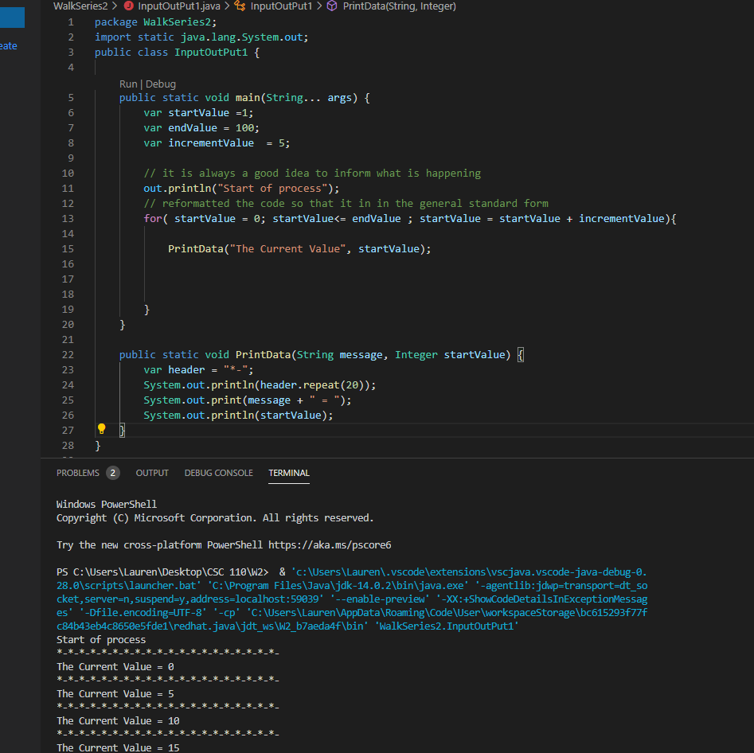

Part c:
The challenge for you is to make the output look like the following, Note the ‘---------------’ are long as the output string. The longer the output the longer the ‘-----------‘.
Start of process
----------------------
The current Value = 0
----------------------

The current Value = 10
-----------------------
The current Value = 95
-----------------------
------------------------
The current Value = 100

I removed the comments in the exercise at this point.
For this portion of the exercise, I created separate variables for value 95 and 100 outside of main, and added another incrementing value. I realized this wasn’t necessary later, as these variable can be created by adding another For loop. I also missed the part in the instructions that asked that the header be as long as the printed text, so this was my original solution for this problem:

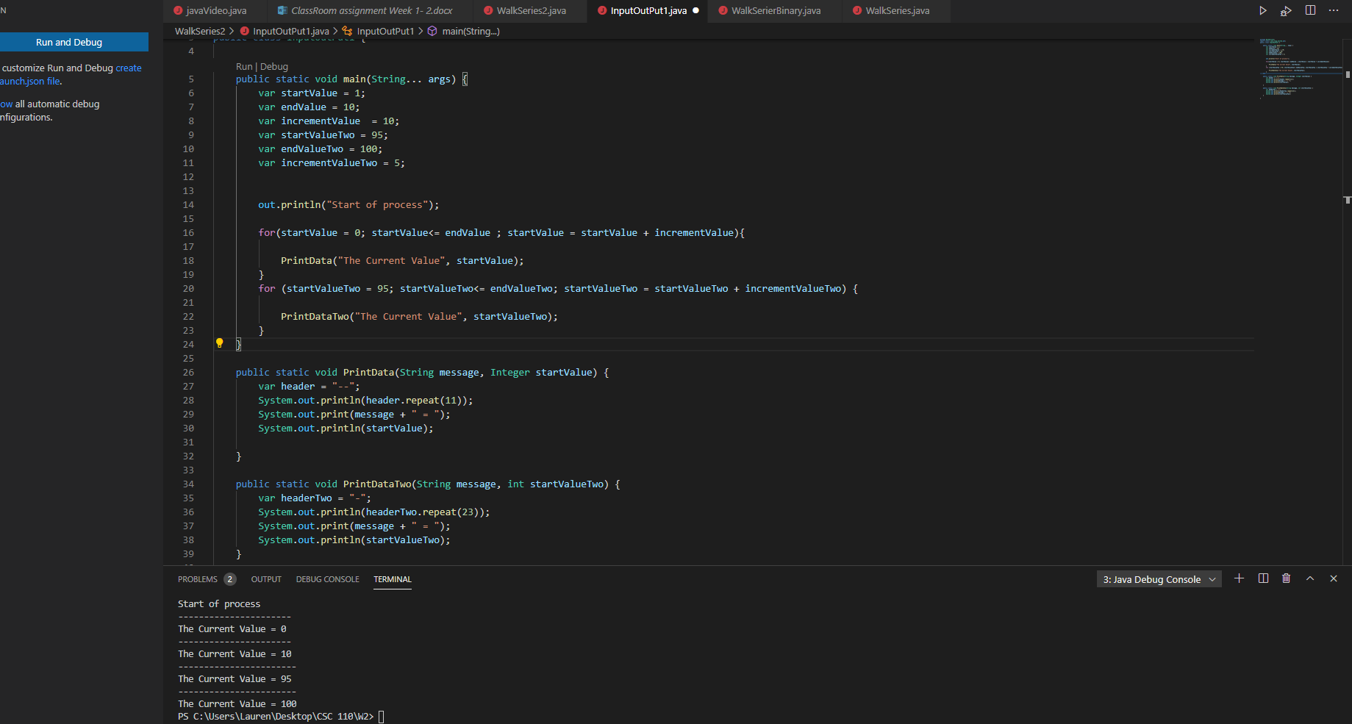

I created two separate methods for the problem. I found out later by changing the code that this wasn’t necessary. I had created another PrintData code segment and separate variables, as well as another string set which wasn’t necessary.

At the time I had made this, I also didn’t know about .length(), so I had the header for The Current Value = 95 and The Current Value = 100 set to repeat the header 23 times (I counted how many dashes there were in the instructions). Again, I misread the instructions. After reading them more carefully, I realized the header length needed to be changed.

I wanted to make it so the header repeated for however many characters were in the statements. I needed to find the string length first, so I Googled “ Java String Length”, and found this article:

https://www.educative.io/edpresso/how-to-find-the-length-of-a-string-in-java
This article helped me find out how to find the length of a string in java.
From there, I knew I could create variables to hold the string length and have my header equal the length of any particular string.
Here was my final result with the header length matching the character length of the following strings:

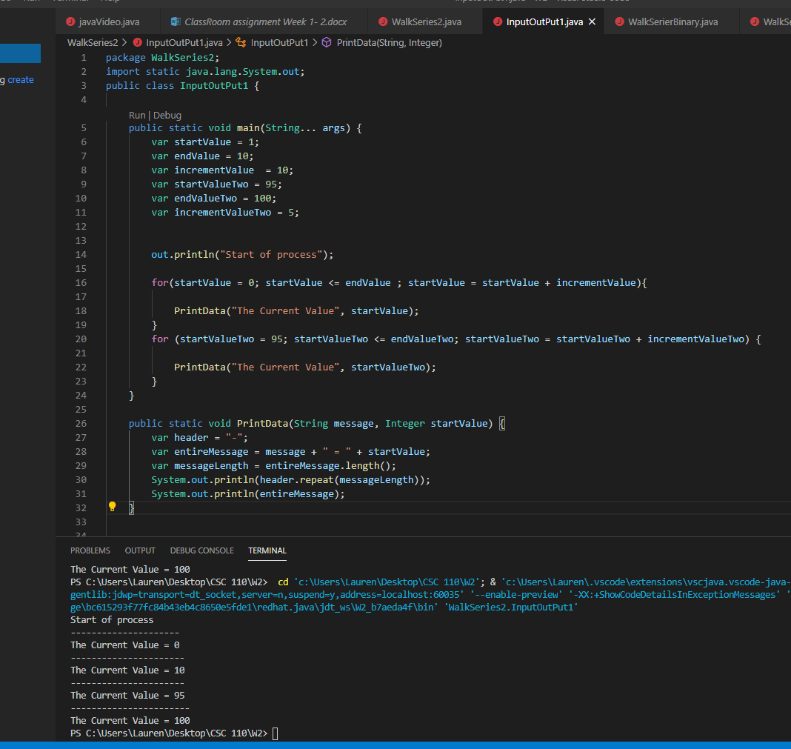

I had to create two separate variables to denote the entire message and the entire message length, and just have the header repeat the message length variable.

I also got rid of the PrintDataTwo set, because this wasn’t necessary with having that second For loop.

Part d:
Read the chapter on Functions:
In your own worlds explain what a difference between Java “Functions” is, “Method”.
What are “Parameters” and “Return” statements.

In Java, a function will return some value when run, which is independent of an object. A method is dependent upon an object.
A parameter is a value that gets passed through a method. Parameters are used as a local variable, and act as variables inside of a method. Parameters are your arguments.
Here is an example of parameters:
int number1 = 4;
int number2 = 20;
int sum = add(number1, number2); // the integers in the parenthesis are parameters, or arguments, for the function add.
Return statements in Java cause program control to go back to a method. You can declare a return type during method declaration.

